**Annexure-I**

**Online Examination System**

*Submitted in partial fulfillment of the*

*requirements for the award of the degree of*

**Bachelor of Computer Applications (BCA)**

To

Guru Gobind Singh Indraprastha University, Delhi



Guide: Submitted By:

**Ms. Kanika Bhalla 1. VIV EK SINGH ADHIKARI 10490302020**

**2. RAKESH KUMAR YADAV 06490302020**

**3. PIYUSH UPADHYAY 35890302020**



**Institute of Innovation in Technology & Management**

**New Delhi – 110058**

**Batch (2020-2023)**

**Certificate**

We, 1. (VIVEK SINGH ADHIAKRI & 10490302020) & 2. (Rakesh Kumar Yadav & 06490302020) & 3. (PIYUSH UPADHYAY 35890302020) certify that the Major Project Report (BCA-356) entitled “**ONLINE EXAMINATION SYSTEM**” is done by us and it is an authentic work carried out by us at Institute of Innovation in Technology & Management. The matter embodied in this project work has not been submitted earlier for the award of any degree or diploma to the best of my knowledge and belief.

1.Signature of the Student 2. Signature of the Student 3. Signature of the Student

Date:

Certified that the Project Report (BCA-356) entitled “**Online Examination System**” done by the above students is completed under my guidance.

Signature of the Guide

Date:

Name of the Guide:

Designation:

Address:

Institute of Innovation in Information

Technology & Management, New

Delhi-110058

Countersigned

Director/Project Coordinator

**TABLE OF CONTENTS**

|  |  |  |  |
| --- | --- | --- | --- |
| **S No** | **Topic** |  | **Page No** |
| 1 | Certificate | | - |
| 2 | Acknowledgements | |  |
| 3 | Abstract | | - |
| 4 | List of Tables | | - |
| 5 | List of | Figures |  |
| 6 | List of Symbols | |  |
| 7 | Chapter-1: Introduction | |  |
|  | 1.1 | Existing System |  |
|  | 1.2 | Problem with Existing System |  |
|  | 1.3 | Proposed System |  |
|  |  | 1.3.1 Aim of the system |  |
|  |  | 1.3.2 Objective of the system |  |
|  |  | 1.3.3 Scope of the system |  |
|  | 1.4 | Methodology of Data Collection |  |
|  |  | 1.4.1 Primary Data Collection |  |
|  |  | 1.4.2 Secondary Data Collection |  |
|  | 1.5 | Methodology of System Design |  |
|  | 1.6 | Implication of System Development Life Cycle |  |
|  | (SDLC) | |  |
|  | 1.7 | System Requirements Tools |  |
|  | 1.8 | Project Planning Gantt Chart |  |
| 8 | Chapter-2: System Requirements Analysis | |  |
|  | 2.1 | System Overview |  |
|  | 2.2 | Identification of actors and their roles in the |  |
|  | System | |  |
|  | 2.3 | System Requirements Specification (SRS) |  |
| 9 | Chapter-3: System Design | |  |
|  | 3.1 | Block Diagram |  |
|  | 3.2 | Database Description |  |
|  | 3.3 | Data Flow Diagram (Context level) |  |
|  | 3.4 | Data Flow Diagram (Level-1) |  |
|  | 3.5 | Entity Relationship Diagram |  |
|  | 3.6 | Use Case Diagram |  |
|  | 3.7 | Sequence Diagram |  |
|  | 3.8 | Site Map |  |
| 10 | Chapter-4: System Development & Implementation | |  |

|  |  |  |  |  |  |  |  |  |
| --- | --- | --- | --- | --- | --- | --- | --- | --- |
|  |  |  | 4.1 | | Webpage Print Layout | | |  |
|  |  |  | 4.2 | | Coding Samples |  |  |  |
|  |  |  | 4.3 | | Database Print Layout | | |  |
|  | 11 |  | Chapter-5: System Testing | | | | |  |
|  |  |  | 5.1 | | Functional Testing | | |  |
|  |  |  | 5.2 | | User Interface Testing | | |  |
|  |  |  |  |  | 5.2.1 Navigation testing | | |  |
|  |  |  |  |  | 5.2.2 Form testing | | |  |
|  |  |  | 5.3 | | Database Testing |  |  |  |
|  | 12 |  | Chapter-6: Scope of | | | Improvement, Summary and | |  |
|  |  |  | Conclusions | | |  |  |  |
|  |  |  | 6.1 | | System Summary (Achieved Objective of | | |  |
|  |  |  | System) | | |  |  |  |
|  |  |  | 6.2 | | Future Scope and Improvisation | | |  |
|  |  |  |  |  |  |  |  |  |
|  |  |  | 6.3 | | Conclusion |  |  |  |
|  |  |  | References / Bibliography | | | | |  |
|  |  |  |  |  | |  |  |  |
|  |  |  | Appendices | | |  |  |  |

**FORMAT FOR LIST OF TABLE/FIGURE**

**LIST OF TABLES**

|  |  |  |
| --- | --- | --- |
| **Table No** | **Title** | **Page No** |
| 1 | Admin |  |
| 2 | Answer |  |
| 3 | Feedback |  |
| 4 | History |  |
| 5 | Options |  |
| 6 | questions |  |
| 7 | quiz |  |
| 8 | rank |  |
| 9 | user |  |

|  |  |  |
| --- | --- | --- |
| **Figure No** | **Title** | **Page No** |
| 1 | Waterfall Model |  |
| 2 | Block Diagram |  |
| 3 | Use Case |  |
| 4 | DFD 0 level |  |
| 5 | DFD 1 level |  |
| 6 | DFD 2 level |  |
| 7 | E-R Diagram |  |
| 8 | Sequence Diagram |  |
| 9 | Site Map |  |

**LIST OF FIGURES**

**Chapter 1 - Problem Definition**

**1. Introduction**

Online examinations contents providers to focus on creating effective assessment questions and focusing on exam’s feedback delivery to students. In the paper we present techniques that are pertinent to the elements of assessment process: answers submission, computerized grading, and feedback after submission.

As the modern organizations are automated and computers are working as per the instructions, it becomes essential for the coordination of human beings, commodity and computers in a modern organization.

The administrators, instructor, Students who are attending for online examination can communicate with the system through this project, thus facilitating effective implementation and monitoring of various activities of Online Examinations like conducting Exams as per scheduled basis and delivering result to that particular use or student. And the details of students who attempted Online Examination are maintained at administrator.

* 1. **Brief Description of System Under Study**

Existing system is a manual one in which users are maintaining books to store the information like Student Details, Instructor Details, Schedule Details and feedbacks about students who attempted exam as per schedule. It is very difficult to maintain historical data.

* 1. **About the Proposed System**

**1.2.1 Objective**

The objective of the Online Examination Tool is to provide better information for the users of this system for better results for their maintenance in student examination schedule details and grading details.

**1.2.2 Purpose**

This application is used to conduct online examination. The students can sit at individual terminals and login to write the exam in the given duration. The questions have to be given to the students. This application will perform correction, display the result immediately and also store it in database. This application provides the administrator with a facility to add new exams. This application provides the instructor add questions to the exam, modify questions in the exam in a particular exam. This application takes care of authentication of the administrator, Instructor as well as the student.

* 1. **Software Model Used**

**Waterfall Model**

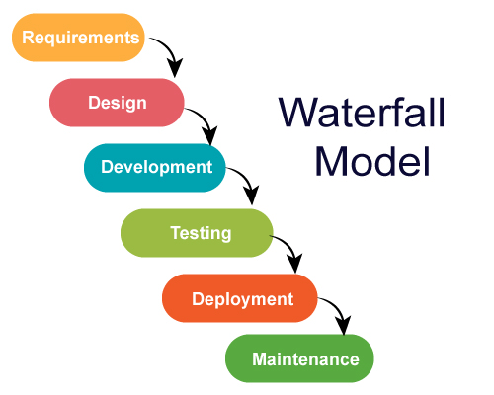

Figure 1 : WATERFALL MODEL

The waterfall model is a linear, sequential approach to the software development life cycle that is popular in software engineering and product development. The waterfall model emphasizes a logical progression of steps. Similar to the direction water flows over the edge of a cliff, distinct endpoints or goals are set for each phase of development and cannot be revisited after completion.

* **Requirements:** Potential requirements, deadlines and guidelines for the project are analyzed and placed into a [functional specification](https://searchsoftwarequality.techtarget.com/definition/functional-specification). This stage handles the defining and planning of the project without mentioning specific processes.
* **Analysis:** The system specifications are analyzed to generate product models and [business logic](https://whatis.techtarget.com/definition/business-logic)  that will guide production. This is also when financial and technical resources are audited for feasibility.
* **Design:** A design specification document is created to outline technical design requirements such as programming language, [hardware](https://techtarget.com/searchnetworking/definition/hardware), data sources, architecture and services.
* **Coding/Implementation:** The [source code](https://searchapparchitecture.techtarget.com/definition/source-code)is developed using the models, logic and requirements designated in the prior stages. Typically, the system is designed in smaller components, or units, before being implemented together.
* **Testing:** This is when [quality assurance](https://searchsoftwarequality.techtarget.com/definition/quality-assurance), [unit](https://searchsoftwarequality.techtarget.com/definition/unit-testing), [system](https://searchsoftwarequality.techtarget.com/definition/system-testing)  and  [beta](https://whatis.techtarget.com/definition/beta-test) tests take place to report issues that may need to be resolved. This may cause a forced repeat of the coding stage for [debugging](https://searchsoftwarequality.techtarget.com/definition/debugging). If the system passes the tests, the waterfall continues forward.
* **Operation/Deployment:** The product or application is deemed fully functional and is deployed to a live environment.
* **Maintenance:** Corrective, adaptive and perfective maintenance is carried out indefinitely to improve, update and enhance the final product. This could include releasing [patch](https://searchenterprisedesktop.techtarget.com/definition/patch)  updates or releasing new versions.

**Advantages of waterfall model**

1. Forces structured, disciplined organization.
2. Is simple to understand, follow and arrange tasks.
3. Allows for early design or specification changes to be made easily.
4. Clearly defines milestones and deadlines.

**Disadvantages of waterfall model**

1. Ignores the potential to receive mid-process user or [client](https://searchenterprisedesktop.techtarget.com/definition/client) feedback and make changes based on results.
2. Delays testing until the end of the development life cycle.
3. Does not handle requests for changes, [scope](https://searchcio.techtarget.com/definition/project-scope) adjustments or updates well.
4. No working product is available until the later stages of the life cycle.

**1.4 Methodology Used for Data Collection**

**Data collection**

Data collection is the process of gathering and measuring information on variables of interest, in an established systematic fashion that enables one to answer stated research questions, test hypotheses, and evaluate outcomes.

**1.4.1 Primary Sources**

Primary resources contain first-hand information, meaning that you are reading the author’s own account on a specific topic or event that he participated in.

* Observation Method
* Interview Method

**1.4.2 Secondary Sources**

A secondary source of information is one that was created later by someone who did not experience first-hand or participate in the events or conditions you're researching.

* Public Records
* Statistical Documents

In this project I have used both sources for data collection, namely: -

1. Observation Method
2. Interview Method
3. Public Records
4. Statistical Documents

**1.5 System Requirement Tools**

**1.5.1 Software Requirements**

* **Tool –** XAMPP
* **Platform –** Web Browser
* **Technology –** PHP, JavaScript, CSS, HTML, SQL

**1.5.2 Hardware Requirements**

* Windows / macOS
* Dual Core processor @ 1.00GHz
* 2GB RAM

**1.6 Gantt chart**

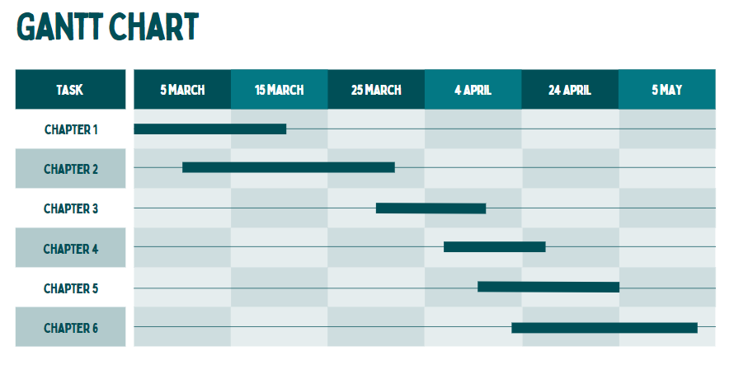

**Chapter 2 - System Analysis**

**Software Requirement Specifications** – A software requirements specification (SRS) is a document that describes what the software will do and how it will be expected to perform. It also describes the functionality the product needs to fulfill all stakeholders (business, users) needs.

* 1. **Introduction**

The following subsections of Software Requirement Specifications Document should facilitate in providing the entire overview of the Information system “**Online Examination System**” under development. This document aims at defining the overall software requirements for your end users. Efforts have been made to define the requirements of the Information system exhaustively and accurately.

* + 1. **Purpose**

The main purpose of Software Requirement Specifications Document is to describe in a precise manner all the capabilities that will be provided by the Software Application “**Online Examination System**”. It also states the various constraints which the system will be abide to. This document further leads to clear vision of the software requirements, specifications and capabilities. These are to be exposed to the development, testing team and end users of the software

* + 1. **Scope**

The online examination system application is vast. It can be used in various sectors, schools, colleges, tuition centres, or individual tutors. It replaces the logistical problems and shortcomings of the conventional pen-and-paper examination mode. It will also reduce the usage of paper and ink. It will save the time which is used in scheduling the exam and improve the management.

* + 1. **References**
* Software engineering (Third edition, k.k Aggarwal and Yogesh singh)
* https://mettl.com/online-exam-software-system/
  + 1. **Overview**

The rest of this SRS document describes the various system requirements, interfaces, features and functionality in detail.

* 1. **Overall description of proposed system**
     1. **Product Perspective**

The application will be windows-based, self-contained and independent software product.

HTML

CSS

JAVASCRIPT

BOOTSTRAP

PHP

PHP

MySQL

* + - 1. **System Interfaces**

None

* + - 1. **Interfaces**

The application will have a user friendly and menu-based interface. Following screens will be provided.

* + A Login Screen for entering username, password and role (Administrator, operator) will be provided. Access to different screens will be based upon the role of the user.
  + A Signup Screen for Registering Details and role (User) will be provided. Details like: (Full Name, Email id, Password, Confirm Password, phone number)
  + A Create Exam Screen For Create Exam for Students/users . Before Create Exam Required details Are: Questions, options, correct answer, time)
    - 1. **Hardware Interfaces**
* **Processor:** Intel Dual Core i3 and above
* **HDD:** Minimum 80GB Disk Space and above
* **RAM:** Minimum 2GB and above
* **OS:** Windows 7 and above, Linux
  + - 1. **Software Interfaces**
* **Database:** MYSQL Server 8.0.30
* **Application:** XAMPP
  + - 1. **Communication Interfaces**

None

* + - 1. **Memory Constraints**

At least 64 mb RAM and 2GB space on hard disk will be required for running the application

* + - 1. **Operations**

This product will not cover any automated housekeeping aspects of database. The DBA at client site will be manually deleting old/ non required data. Database backup and recovery will also have to be handled by DBA.

* + - 1. **Site Adaptation Requirement**

The terminals at the client side will have to support the hardware and software interfaces specified.

* + 1. **Product functions**

The system will allow access only to authorized users with specific roles (Administrator, Operator). Depending upon the user’s role, he/she will be able to access only specific modules of the system.

A summary of the major functions that the software will perform:

* **Login Facility: -** Used for the admin and users for login into the program. This provide various facility according to the type of user(admin or user).
* **Create Exam: -** This is also an essential function that handles all aspects of creating exam.
* **Users: -** Users can give exam or create own exam.
  + 1. **User Characteristics**
* Educational Level: At least graduate and should be comfortable with English language.
* Technical Expertise: Should be a high or middle level employee of the organization comfortable with using general purpose applications on a computer
  + 1. **Constraints**

None

* + 1. **Apportioning Requirement**

Not Required

* 1. **Specific Requirements**

This section contains the software requirements to a level of detail sufficient to enable designers to design the system, and testers to test the system.

* + 1. **External Interfaces**
       1. **User Interfaces**

The following screens will be provided:

* All the users will see the same page when they enter in this website. This page asks the users a username and a password.
* After being authenticated by correct username and password, user will be redirect to their corresponding profile where they can do various activities.
* The user interface will be simple and consistence, using terminology commonly understood by intended users of the system. The system will have simple interface, consistence with standard interface, to eliminate need for user training of infrequent users.
  + - 1. **Hardware Interfaces**
* No extra hardware interfaces are needed.
* The system will use the standard hardware and data communication resources.
* This includes, but not limited to, general network connection at the server/hostingsite, network server and network management tools.
  + - 1. **Software interfaces**
* **OS:** Windows 7, Linux Web
* **Browser:** The system is a web-based application; clients need a modern web browser such as Mozilla Firebox, Internet Explorer, Opera, and Chrome.
  + - 1. **Communication Interfaces**

None

* + 1. **System Features**

**Creating Exam:** Using this module user can create or exam and know the details for various types of exams.

1. **Validity Checks:**

* Name should not blank.
* Type must be specified
* User should enter address.
* Phone No and Email should be filled.

1. **Sequencing Information**

* Firstly, user enter exam name.
* Then he/she enter question.
* After this user enter answer options.
* Then, user select correct answer
* Then, user create.
* At last user enter required time.

1. **Error Handling / Response to abnormal situations:**

* If user left any field blank then it shows an error.
* If booking is successful then it shows a message above form regarding successful booking.
  + 1. **Performance Requirements**

None

* + 1. **Logical Database Requirements**

The proposed information system contains the following data tables in its database collection.

1. **admin**

EMAIL ID

PASSWORD

1. **answer**

QID

ANSID

1. **feedback**

ID

NAME

EMAIL

SUBJECT

FEEDBACK

DATE

TIME

1. **history**

EMAIL

EID

SCORE

LEVEL

CORRECT WRONG

TIME

1. **options**

QID

OPTION

OPTIONID

1. **questions**

EID

QID

QNS

CHOICE

SN

1. **quiz**

EID

TITLE

CORRECT

WRONG

TOTAL

TIME

INTRO

TAG

DATE

1. **rank**

EMAIL

SCORE

TIME

1. **user**

NAME

GENDER

COLLEGE

EMAIL

MOB

PASSWORD

* + 1. **Design Constraints**
       1. **Standard Compliance**

None

* + 1. **Software System Attributes**
* Reliability

This application is a reliable product that produces fast and verified output of all its processes.

* Availability

This application will be available to use for your end users and help them to carry out their operations conveniently.

* Security

The application will be password protected. User will have to enter correct username, password and role in order to access the application.

* Maintainability

The application will be designed in a maintainable manner. It will be easy to to incorporate new requirements in the individual modules.

* Portability

The application will be easily portable on any windows-based system that has oracle installed.

* + 1. **Other Requirements**

None

1. **Methodologies for Data Collection**
   1. **Primary Data Collection**

Data that has been collected from first-hand-experience is known as primary data. Primary data has not been published yet and is more reliable, authentic and objective. Primary data has not been changed or altered by human beings; therefore its validity is greater than secondary data.

Primary sources can include ;

1. Interviews, diaries, letters, journals, speeches, autobiographies, and witness statements.
2. Articles containing original research, data, or findings never before shared.
3. Original hand-written manuscripts.
4. Government documents and public records.
5. Art, photographs, films, maps, fiction, and music.
   1. **Secondary Data Collection**

Data collected from a source that has already been published in any form is called as secondary data. The review of literature in nay research is based on secondary data. Mostly from books, journals and periodicals.

Secondary sources can include ;

1. Textbooks
2. Review articles and critical analysis essays
3. Biographies
4. Historical films, music, and art
5. Articles about people and events from the past

## Chapter 3 - System Design

1. **Physical Design**

The physical design relates to the actual input and output processes of the system. This is laid down in terms of how data is input into a system, how it is verified/authenticated, how it is processed, and how it is displayed as In Physical design, following requirements about the system are decided.

1. Input requirement,
2. Output requirements,
3. Storage requirements,
4. Processing Requirements

**Block Diagram**

Online Examination System

User Details

Create Exam

Exam Result

Profile Verified

Give Exam

FIGURE 2: BLOCK DIAGRAM

**Use Case**

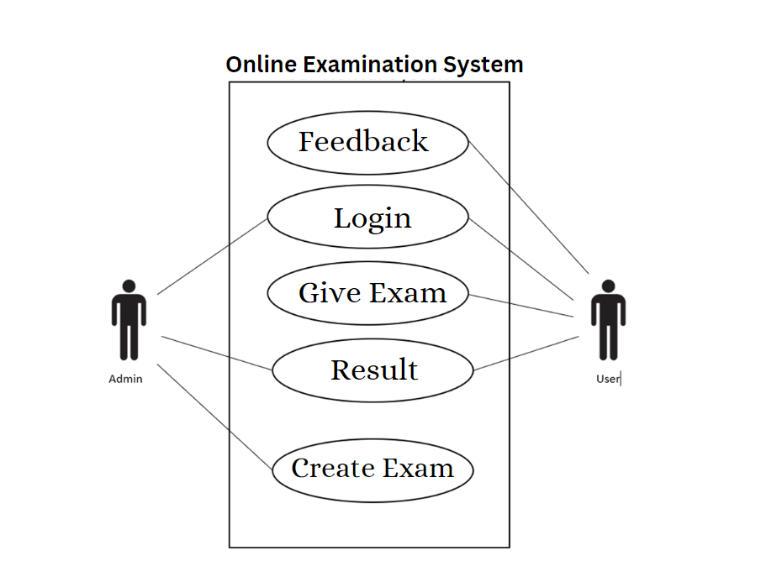

Figure 3: USE CASE

1. **DFD**

**0 level Data Flow Diagram (DFD)**

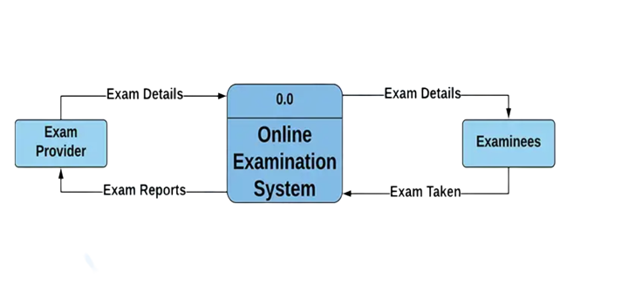

Figure 4: 0 level Data Flow Diagram (DFD)

**1 level Data Flow Diagram**

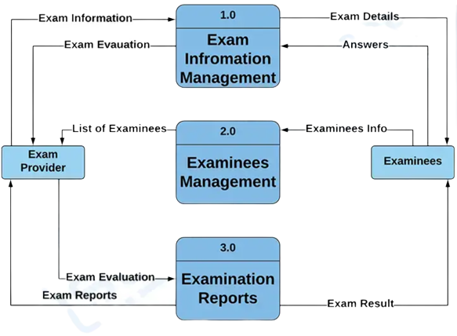

Figure 5: 1 level Data Flow Diagram (DFD)

**2 level Data Flow Diagram (DFD)**

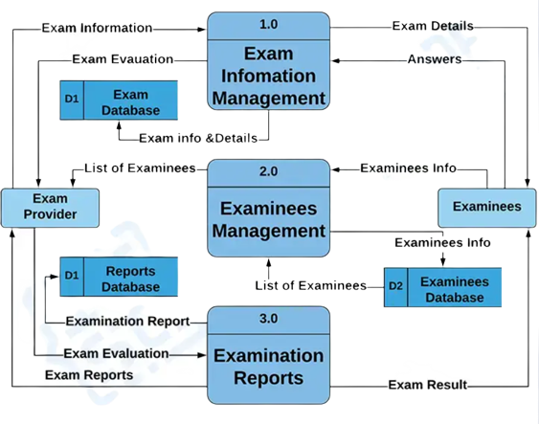

Figure 6: 2 level Data Flow Diagram (DFD)

1. **ER Diagram**

User

Send

Feedback

Create

Admin

Give Exam

Exam

Figure 7: E – R DIAGRAM

**Sequence Diagram**

Sequence diagram and collaboration diagram are called INTERACTION DIAGRAMS. An interaction diagram shows an interaction, consisting of set of objects and their relationship including the messages that may be dispatched among them.

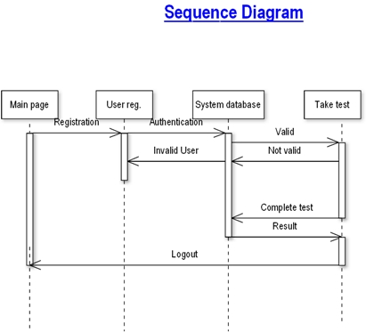

Figure 8: SEQUENCE DIAGRAM

**Database Design**

The information system of “Online Examination System” performs its function with the help of the data store in certain repositories called Databases of the system. Detailed descriptions of the various databases included in the information systems are tabulated as follows:

admin

|  |  |  |  |  |  |
| --- | --- | --- | --- | --- | --- |
| S No | Field Name | Field Type | Field Size | Constraint | Description |
| 1 | email | varchar | 50 | primary key | email of the user |
| 2 | password | varchar | 500 | not null | password of the user |

answer

|  |  |  |  |  |  |
| --- | --- | --- | --- | --- | --- |
| S No | Field Name | Field Type | Field Size | Constraint | Description |
| 1 | qid | varchar | 30 | not null | question id |
| 2 | ansid | varchar | 30 | primary key | answer id |

feedback

|  |  |  |  |  |  |
| --- | --- | --- | --- | --- | --- |
| S No | Field Name | Field Type | Field Size | Constraint | Description |
| 1 | id | text |  | not null | feedback id |
| 2 | name | varchar | 50 | not null | name of the sender |
| 3 | email | varchar | 50 | primary key | email of the user |
| 4 | subject | varchar | 500 | not null | subject of the feedback |
| 5 | feedback | varchar | 500 | not null | description of the feedback |
| 6 | date | date |  | not null | current date |
| 7 | time | varchar | 50 | not null | current time |

history

|  |  |  |  |  |  |
| --- | --- | --- | --- | --- | --- |
| S No | Field Name | Field Type | Field Size | Constraint | Description |
| 1 | email | varchar | 40 | not null | email of the user |
| 2 | eid | text |  | not null | unique user id generated by the system |
| 3 | score | int | 11 | not null | score of the student |
| 4 | level | int | 11 | not null | level of the student |
| 5 | correct | int | 11 | not null | no. of correct answer |
| 6 | wrong | int | 11 | not null | no. of wrong answer |
| 7 | date | timestamp |  | primary key | current time |

options

|  |  |  |  |  |  |
| --- | --- | --- | --- | --- | --- |
| S No | Field Name | Field Type | Field Size | Constraint | Description |
| 1 | qid | varchar | 50 | not null | question id |
| 2 | option | varchar | 50 | not null | options of the question |
| 3 | optionid | varchar | 30 | primary key | option id |

questions

|  |  |  |  |  |  |
| --- | --- | --- | --- | --- | --- |
| S No | Field Name | Field Type | Field Size | Constraint | Description |
| 1 | eid | text |  | not null | unique user id generated by the system |
| 2 | qid | varchar | 30 | primary key | question id |
| 3 | qns | text |  | not null | question |
| 4 | choice | int | 10 | not null | number of options |
| 5 | sn | int | 11 | not null | correct option |

quiz

|  |  |  |  |  |  |
| --- | --- | --- | --- | --- | --- |
| S No | Field Name | Field Type | Field Size | Constraint | Description |
| 1 | eid | text |  | not null | unique user id generated by the system |
| 2 | title | varchar | 100 | not null | title of the quiz |
| 3 | correct | int | 11 | not null | number of correct answers |
| 4 | wrong | int | 11 | not null | number of wrong answers |
| 5 | total | int | 11 | not null | total score |
| 6 | time | bigint | 20 | not null | total quiz time |
| 7 | intro | text |  | not null | a brief introduction of quiz |
| 8 | tag | varchar | 100 | not null | tags |
| 9 | date | timestamp |  | primary key | current date |

rank

|  |  |  |  |  |  |
| --- | --- | --- | --- | --- | --- |
| S No | Field Name | Field Type | Field Size | Constraint | Description |
| 1 | email | varchar | 50 | primary key | email of the user |
| 2 | score | int | 11 | not null | total score secured by student |
| 3 | time | timestamp |  | not null | current time |

user

|  |  |  |  |  |  |
| --- | --- | --- | --- | --- | --- |
| S No | Field Name | Field Type | Field Size | Constraint | Description |
| 1 | name | varchar | 50 | not null | name of the student |
| 2 | gender | varchar | 5 | not null | gender of the student |
| 3 | college | varchar | 100 | not null | college of the student |
| 4 | email | varchar | 50 | primary key | email of the user |
| 5 | mob | bigint | 20 | not null | mobile number of the student |
| 6 | password | varchar | 50 | not null | password of the user |

1. **Site Map**

A site map (or sitemap) is a list of pages of a web site accessible to crawlers or users. Sitemaps to provide site with metadata about specific types of content on your site, including video, images, mobile, and News. For example, a video Sitemap entry can specify the running time, category, and family-friendly status of a video; an image Sitemap entry can provide information about an image’s subject matter, type, and license. You can also use a Sitemap to provide additional information about your site.

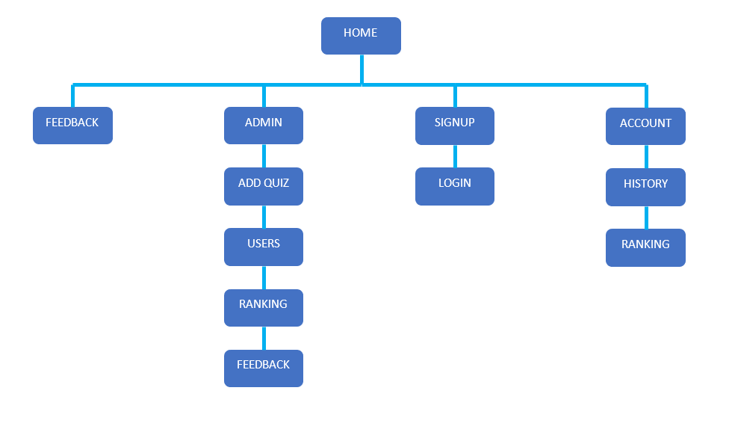

Figure 9: SITE MAP

### **Chapter-4: Systems Development, Testing &Implementation**

**Purpose**: To carry out the activities of writing actual programmes, their debugging, testing and validation. Following activities are to be carried out:

1. **Programme Development**: Develop the programs using the tools/platform specified in Chapter-1 (both back-end and front-end). Attach programme codes, screen prints of GUI and ‘Actual Output Reports’ using the real data. Codes may be attached as appendix & on CD.

**HOME**

Home page is use to create new user by enter your Name, Select Gender (Male/Female), Enter College Code, Enter Email Id And user phone number, then create your password and reconfirm password for create new user.

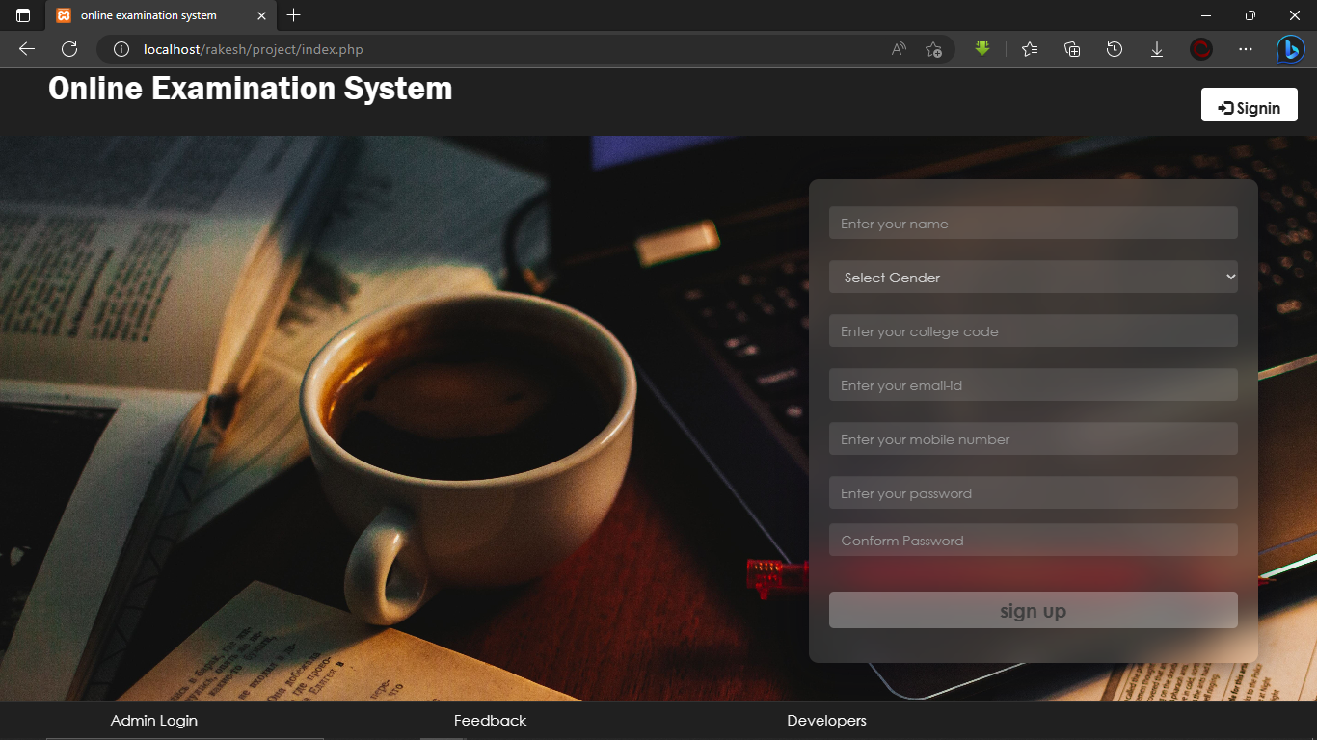

Figure 4.1: Home page

**LOGIN**

In login page, user can able to account login in website by entering email id and password which created in home page.

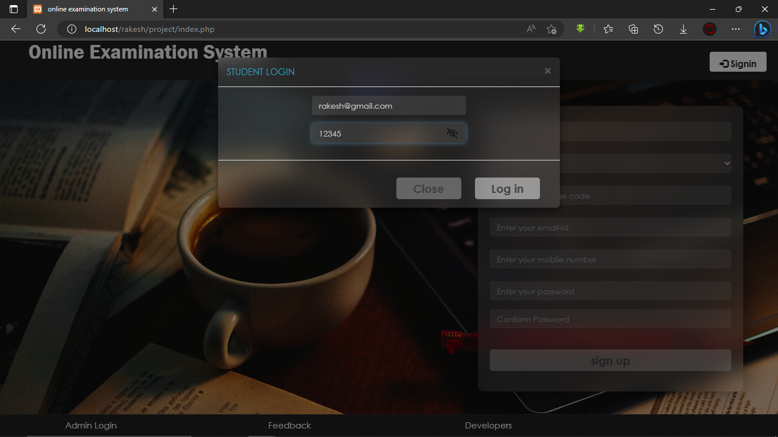

Figure 4.2: login page

**FEEDBACK**

Feedback page is use to give feedback to admin directly by enter name subject of feedback and your valid email address and then enter your feedback.

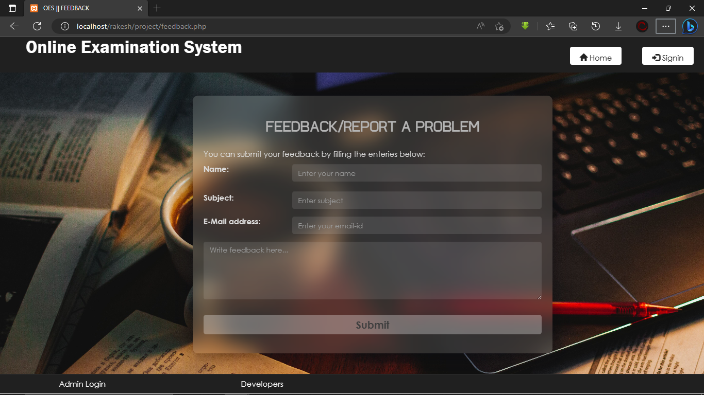

Figure 4.3: feedback page

**STUDENT DASHBOARD**

In student dashboard, students are able to see their exam details.

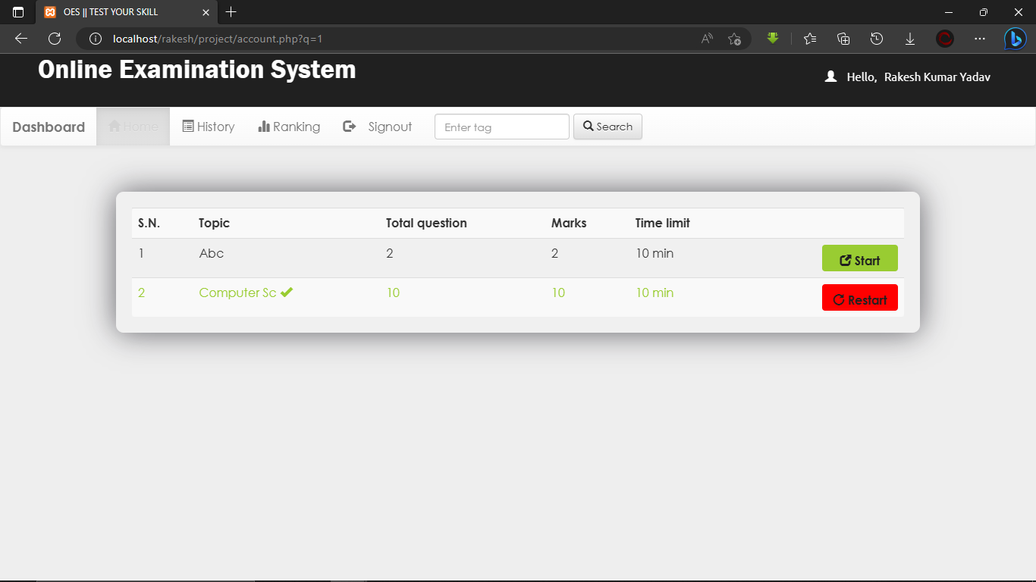

Figure 4.4: student dashboard page

**STUDENT RANKING**

In student ranking, students are able to see their score of exams.

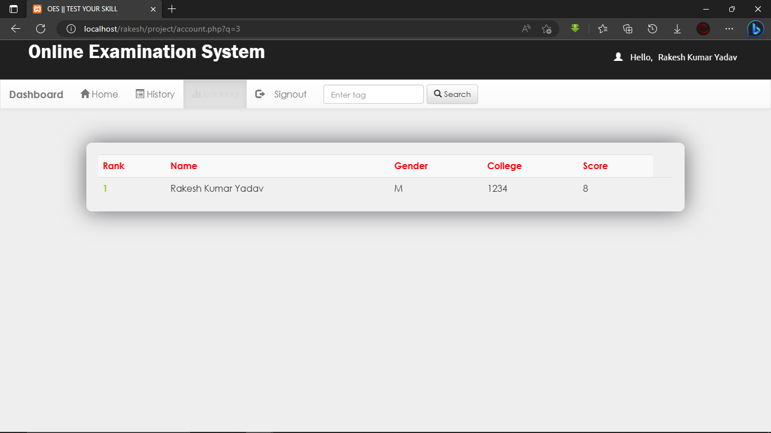

Figure 4.5: Student Ranking page

**TEST QUESTIONS**

In test page, the test will solve by the students.

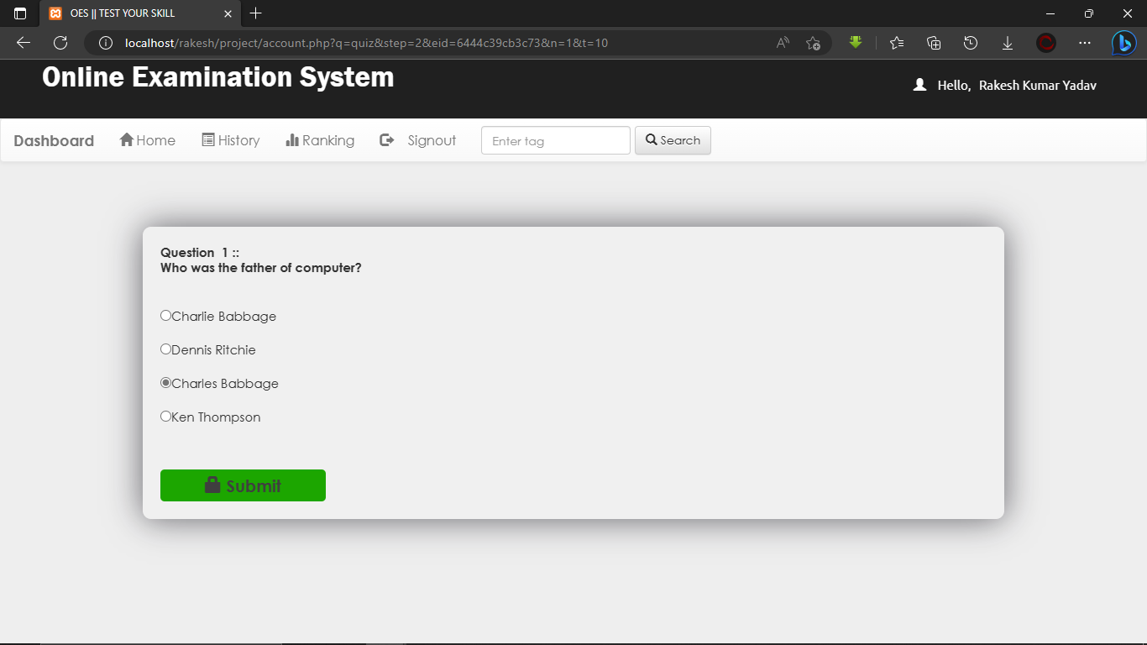

Figure 4.6: Test page

**RESULT**

In result page students are able to see their score and result of exam.

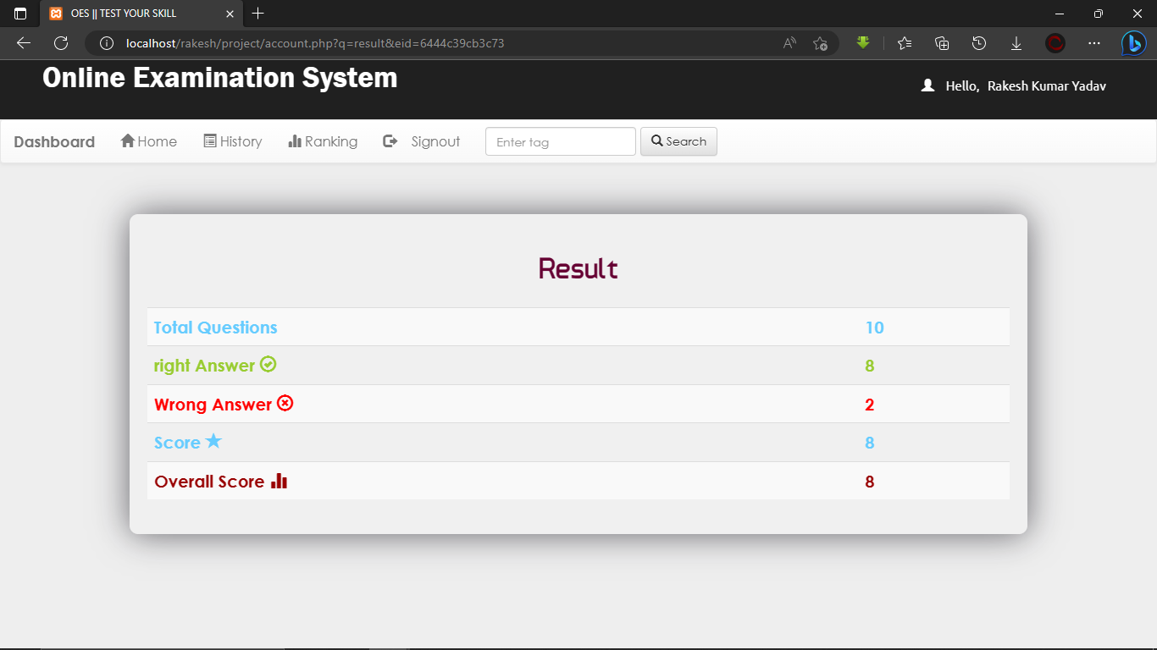

Figure 4.7: Result page

**ADMIN DASHBOARD**

Admin Dashboard is managed by admin, create exam and manage the exam.

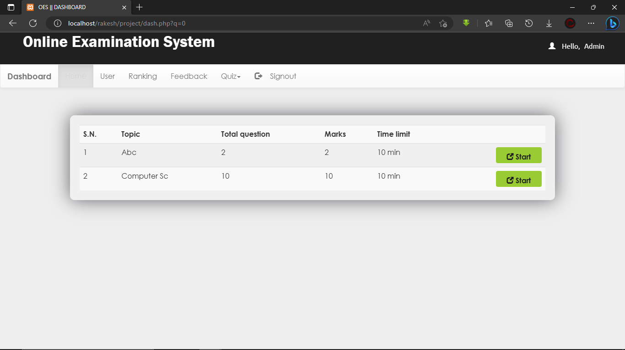

Figure 4.8: Admin Dashboard page

**USER LIST**

All the users are listed here, it can be accessed by admin.

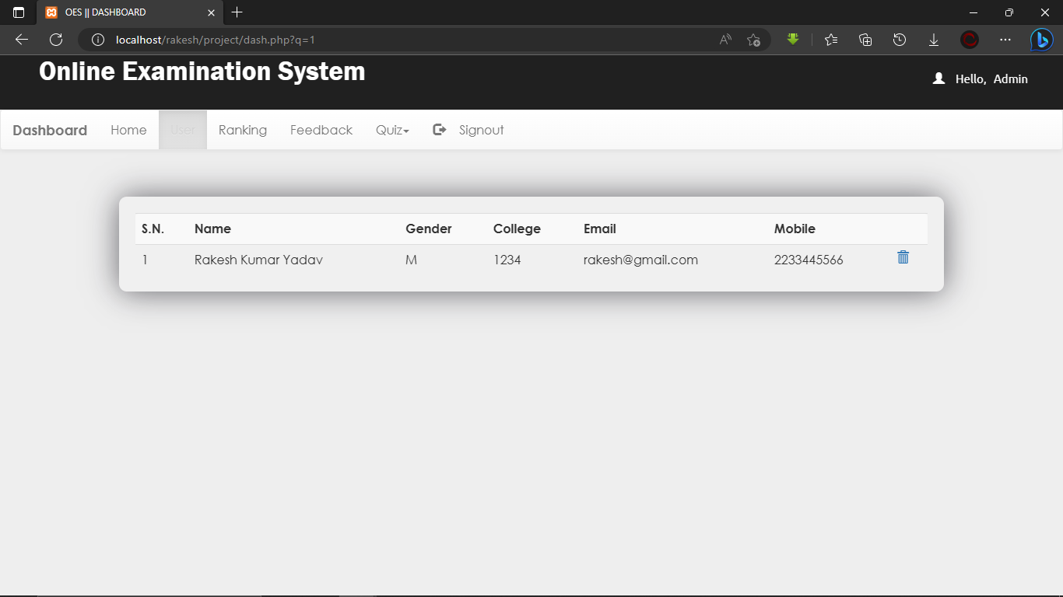

Figure 4.9: User list page

**ADD QUIZ**

Exam is created by admin.

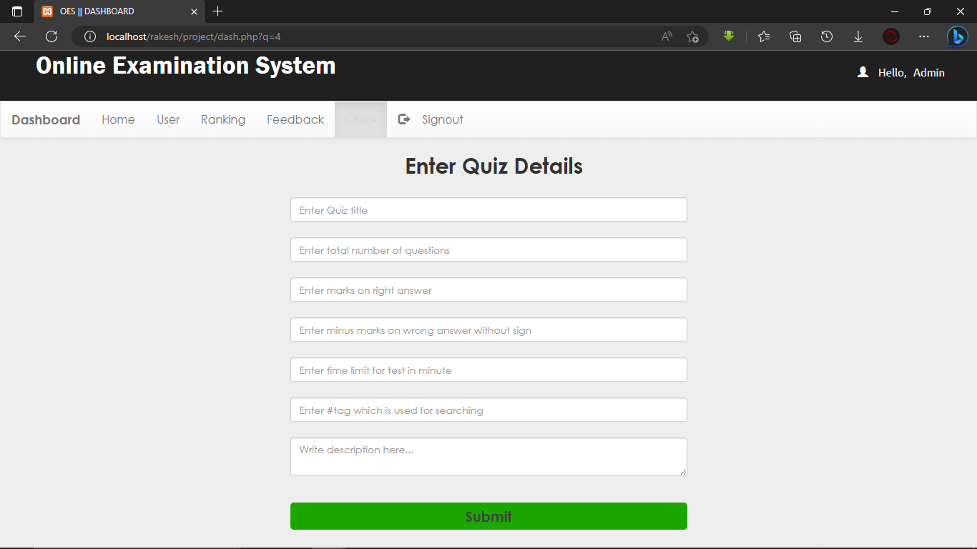

Figure 4.9: Add Exam page

**REMOVE QUIZ**

Created exam can be removed by admin.

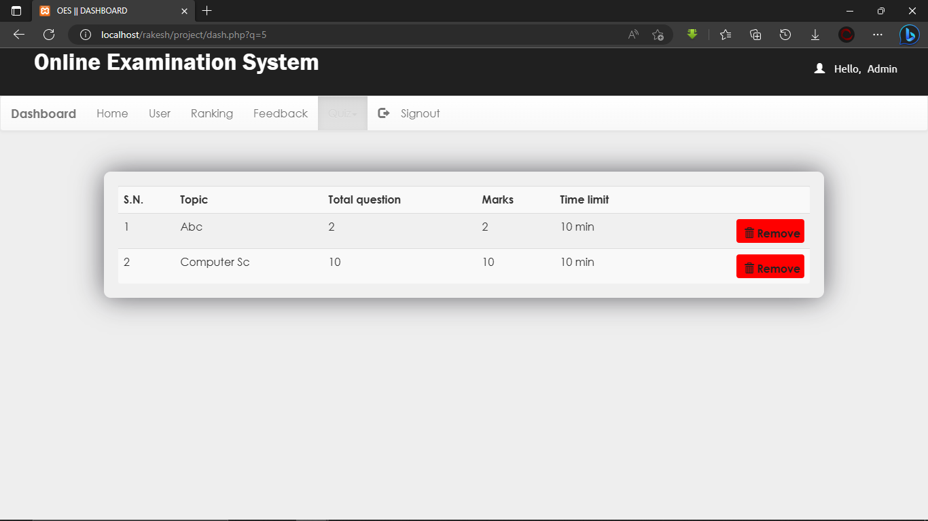

Figure 4.8: Remove Exam page

**Chapter-5: System Testing**

**Testing & Debugging**: Use *Past Data* to check whether the programmed work as intended by you or you can use dummy data.

|  |  |  |  |  |  |
| --- | --- | --- | --- | --- | --- |
| Login | | | | | |
| Input | | | | Output | |
| Actual | | Expected | | Actual | Expected |
| Username | Password | Username | Password |  |  |
| rakesh@gmail.com | 12345 | rakesh@gmail.com | 12345 | Login Successful | Login Successful |
| piyush@gmail.com | 00000 | piyush@gmail.com | 54321 | Login Unsuccessful | Login Unsuccessful |
| vivek@gmail.com | 12345 | vivek@gmail.com | 67890 | Login Unsuccessful | Login Unsuccessful |
| Empty Field | Empty Field | Username | Password | Please enter username/password | Login Unsuccessful |

|  |  |  |  |
| --- | --- | --- | --- |
| Quiz | | | |
| Input | | Output | |
| Actual Data | Expected Data | Actual | Expected |
| choosing one of the options | choose one of the options to answer the question | Submit Successful | Submit Successful |
| Empty Field | choose one of the options to answer the question | Please select an option | Select an option before submitting |
|  |  |  |  |

|  |  |  |  |
| --- | --- | --- | --- |
| Feedback | | | |
| Input | | Output | |
| Actual Data | Expected Data | Actual | Expected |
| All the fields are filled properly | all the field must be filled | Submit Successful | Submit Successful |
| Empty Field | all the field must be filled | Please fill this field | Fill all the fields first |

|  |  |  |  |
| --- | --- | --- | --- |
| Create Exam | | | |
| Input | | Output | |
| Actual Data | Expected Data | Actual | Expected |
| All the fields are filled properly | all the field must be filled | Submit Successful | Submit Successful |
| Empty Field | all the field must be filled | Please fill this field | Fill all the fields first |

**Chapter-6: Scope of Improvement, Summary and Conclusions**

Describe what has been achieved vis-à-vis objectives & scope of the project. Is the application developed by you ready for use or some bugs remain? Describe limitations and scope for future development/improvement.

**OBJECTIVE**

The objectives of online examination system is to make sure that the student is thoroughly ware of the course curriculum and that the exam reflects the course content he/she has studied. It will automate the process of assessing students' subject knowledge. The platform is preferred by universities and colleges as it replaces the logistical problems and shortcomings of the conventional pen-and-paper examination mode.

**SCOPE**

The online examination system application is vast. It can be used in various sectors, schools, colleges, tuition centers, or individual tutors. It replaces the logistical problems and shortcomings of the conventional pen-and-paper examination mode. It will also reduce the usage of paper and ink. It will save the time which is used in scheduling the exam and improve the management.

**DRAWBACKS / LIMITATIONS**

**Network Issue:** One of the biggest challenges in conducting online examinations is connectivity. If any network issue occurs during the exam, the online test can be delayed or postponed. The exams can indeed be taken some other time, but it negatively affects the students' minds.

**Security Issue:** In online examinations, data are shared online and stored in cloud-based storage. But being in a totally online environment brings the risk of data breach and hacking. Suppose Hackers can get into the online examination system. In that case, they can completely sabotage the data and may even extract question papers. Not every type of question can be checked automatically with the Online examination system. While online evaluation is excellent for short multiple-choice questions, they are not useful for broad questions. Teachers have to manually check the answers and grade the students.

**Accessibility:** India is still a developing country. And rural areas are yet not connected through the internet or have computer systems. Under such conditions, conducting online examinations in such places is a faraway dream.